**SASS**

1. Install ruby
2. Ruby gem

https://www.youtube.com/watch?v=OHgXELONyTQ

1. Check sass by command (Sass --? )

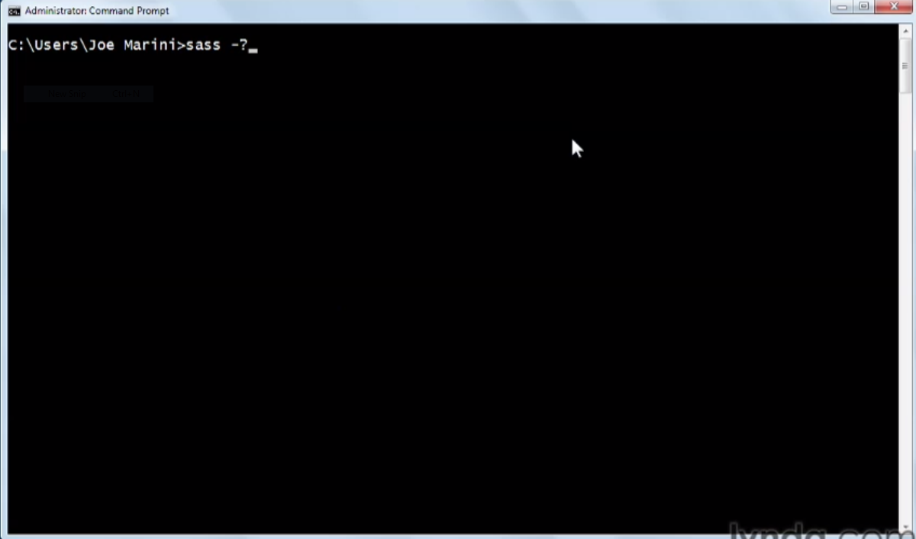

1. Use commad to convert sass file into css file.

sass –update file_name.scss

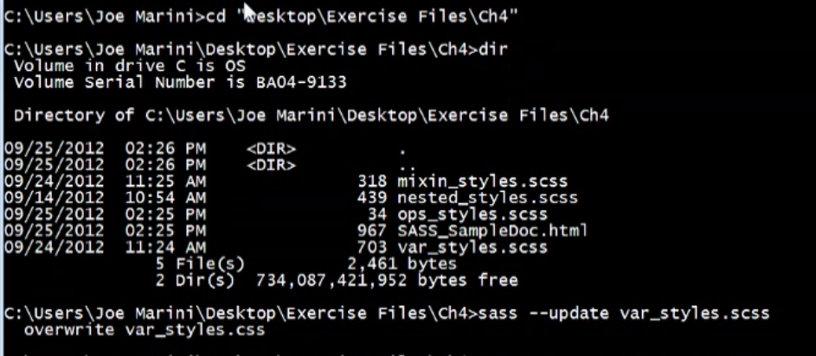

1. If u want to save css file with your desired file name

sass –update file_name.scss:mysheet.css



1. If you wand to convert whole directory

sass –update folder_name:folder_name

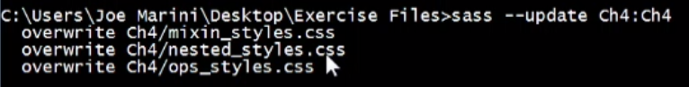

sass –watch folder_name:folder_name

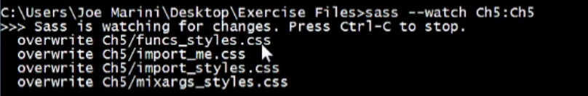

1. **Variables:**

Declare with $ sign.

Like $myfirstvariable

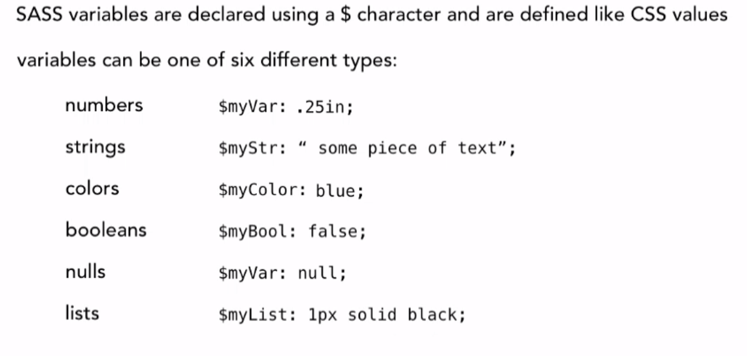

1. **Mixins**:

@mixin .class1{

(any style)

}

header{

@include class1;

}

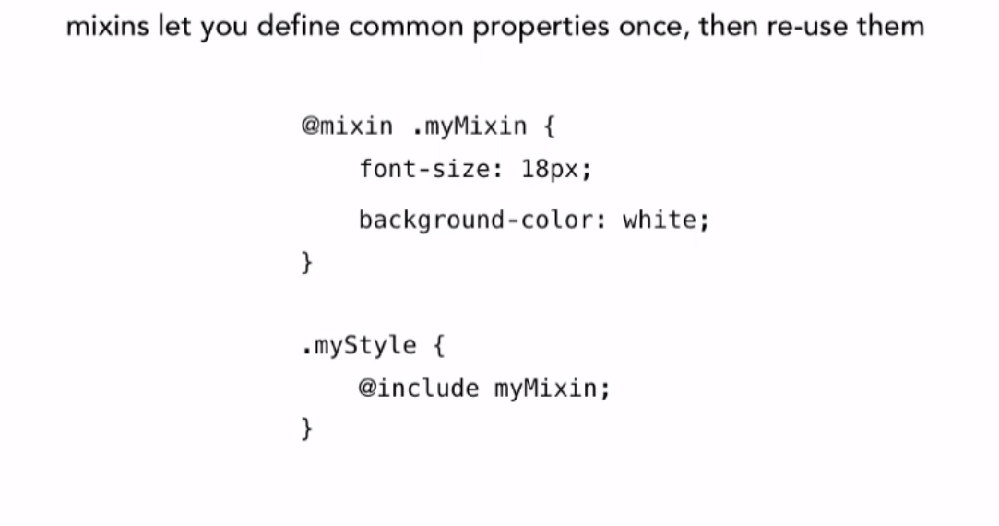

1. **Nested Rules:**

.content{

p{

(any style)

}

a{

(any style)

&:hover{

(any style)

}

}

}

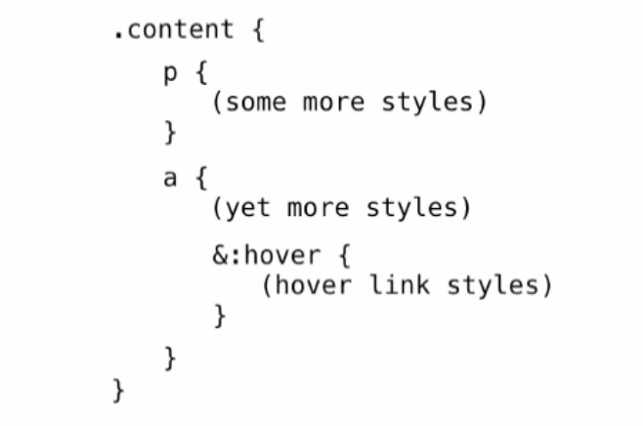

1. **Operations:**

@var=#069;

#mypar{

color: @var + #00f;

padding: @var @var+20;

border: (@var+11)/2 solid black;

}

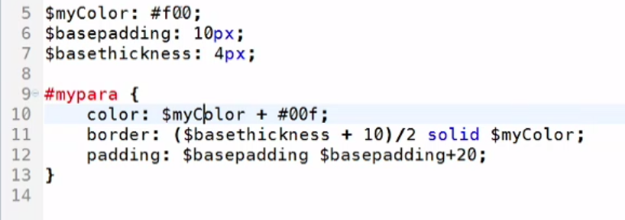

1. **Conditional Operations:**

$gender=boy;

$mycolor : if($gender==”boy”,#00F,#069);

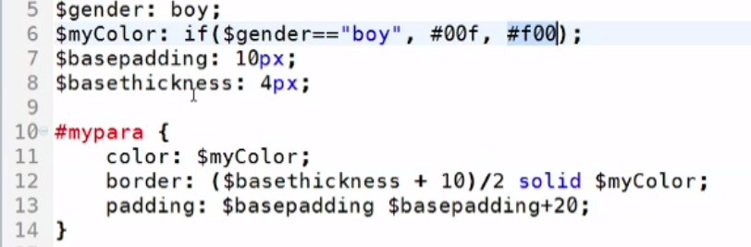

**ADVANCED SASS**

1. **Mixins with Arguments:**

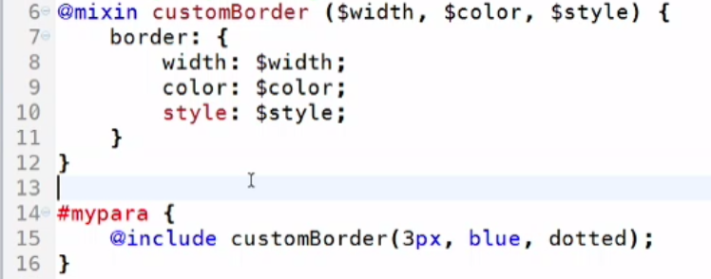

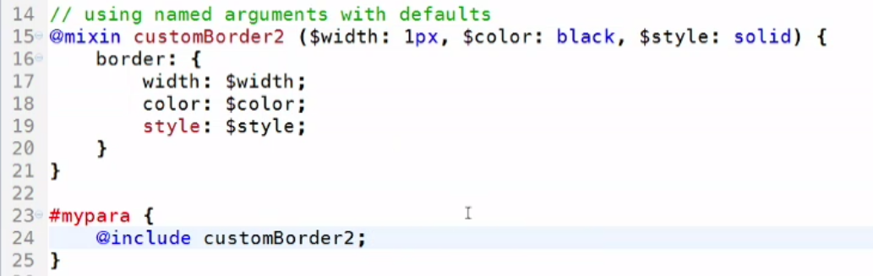

1. **Functions:**

**Build-in:**

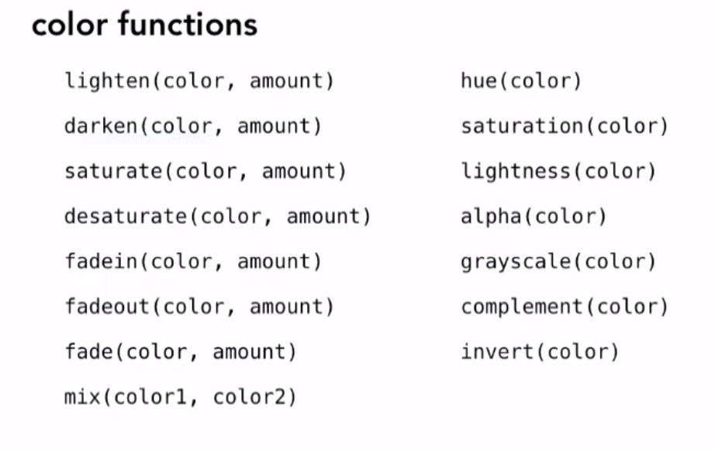

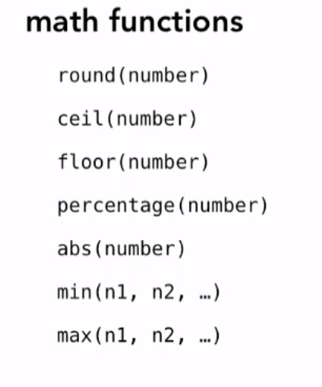

Example:

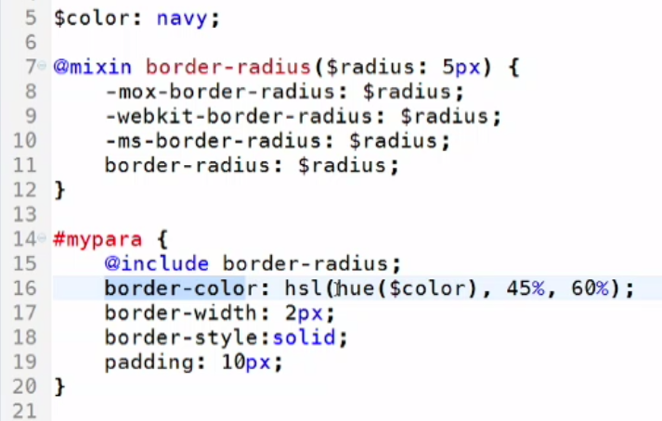

1. **Output Formation:**

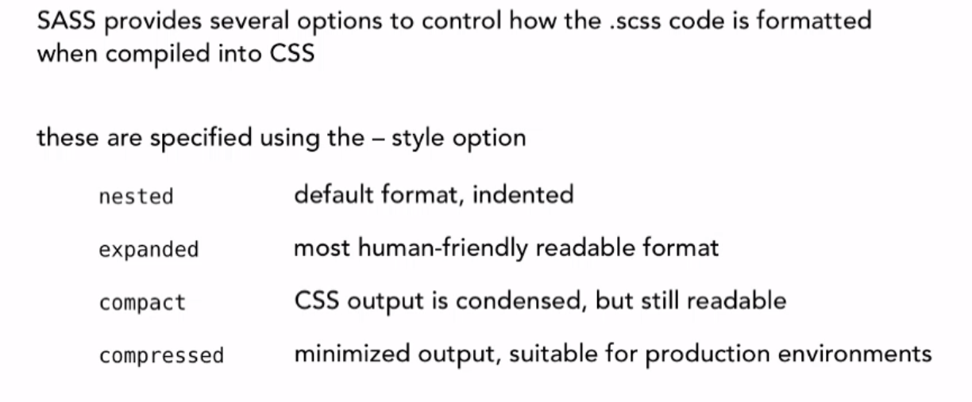

Expended:

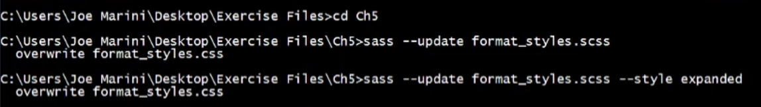

Compact:



Compressed:



1. **Import:**



**LESS**

*First Download less javascript file.*

1. **Variables:**

Declare with @ sign.

Like @myfirstvariable

Example:

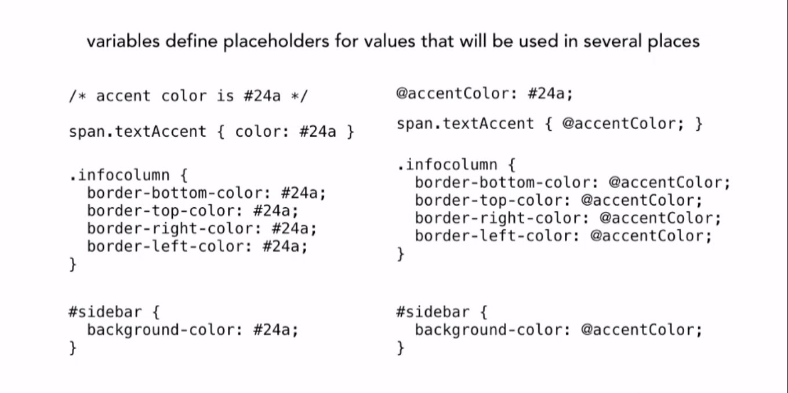

1. **Mixins**:

.class1{

(any style)

}

header{

(any style)

.class1;

}

Example:

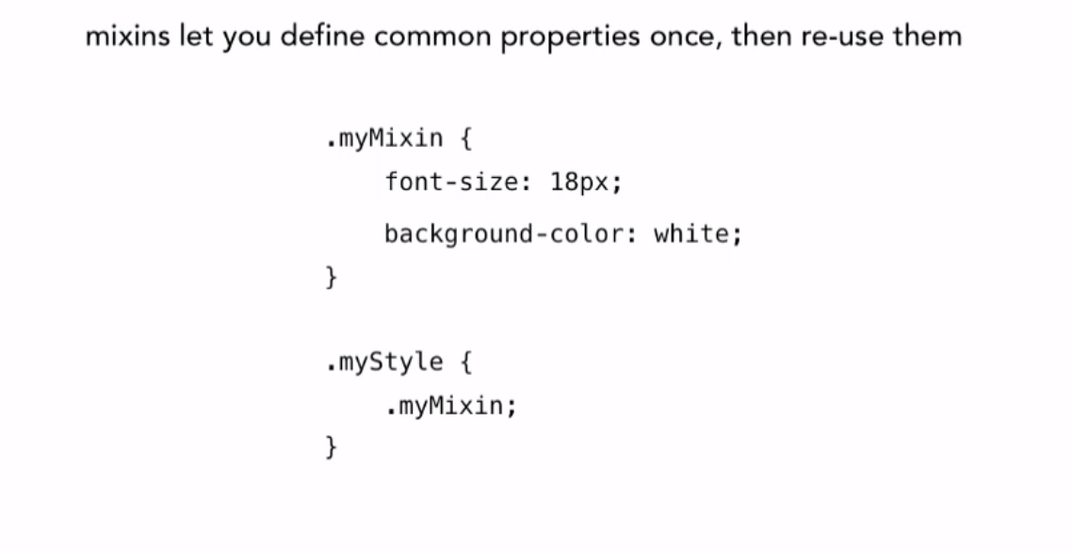

1. **Nested Rules:**

.content{

p{

(any style)

}

a{

(any style)

&:hover{

(any style)

}

}

}

With CSS:

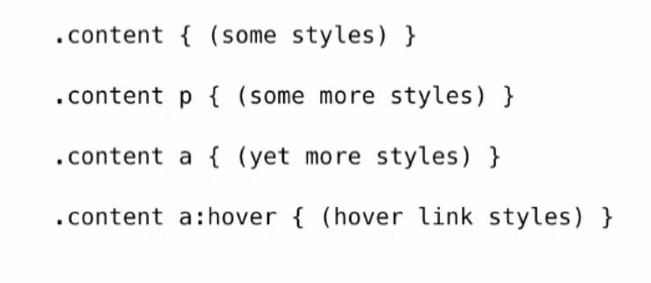 With LESS:

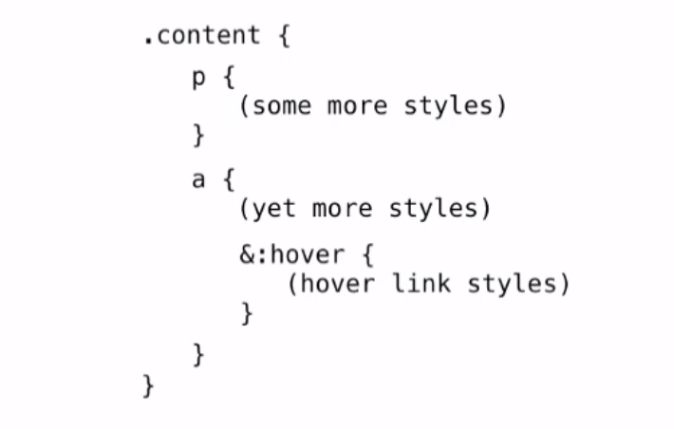

1. **Operations:**

@var=#069;

#mypar{

color: @var + #00f;

padding: @var @var+20;

border: (@var+11)/2 solid black;

}

Example:

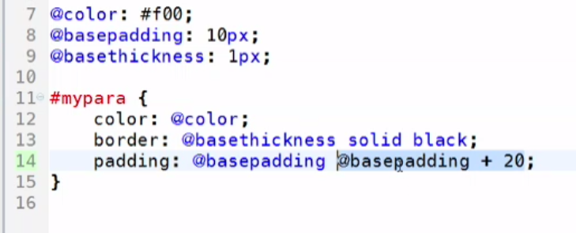

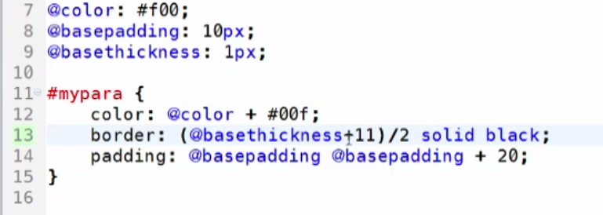

**Note: Use Simpless compiler to convert less file into css file.**

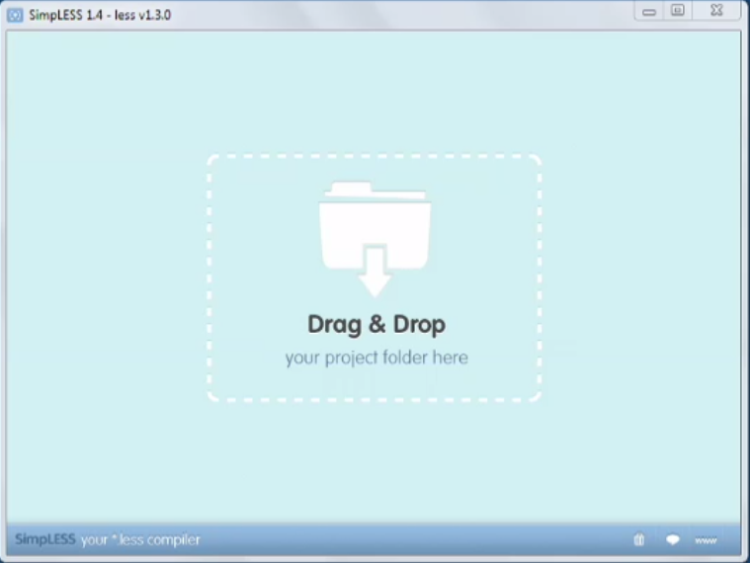

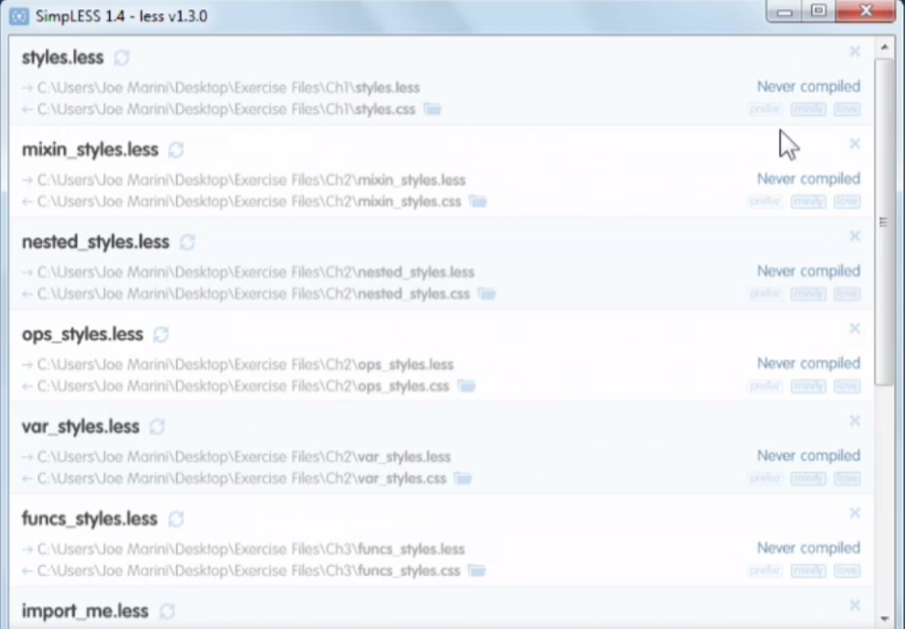

**Prepared By Mee**